Week 5 Project Closure Report
Project Title: Campus Cultural Fest Operations Dashboard & Process Optimization System
Project Overview
The Campus Cultural Fest Operations Dashboard & Process Optimization System was developed to improve visibility into event operations and provide centralized reporting for registrations, attendance, volunteer activities, and incident management.
The project simulated the role of an Operations Coordinator responsible for managing a large-scale campus cultural fest involving multiple events, volunteers, participants, and faculty coordinators.
The project was completed over a five-week period using project management, database, data analysis, and dashboard development techniques.
Project Objectives
The following objectives were established during project initiation:
Objective | Status
Develop a centralized event operations tracking system | Achieved
Create a structured project management framework | Achieved
Design and implement a relational database | Achieved
Generate and analyze operational data | Achieved
Define and monitor key performance indicators | Achieved
Develop an interactive dashboard using Looker Studio | Achieved
Produce project documentation and reports | Achieved
Project Deliverables Completed
Week 1 – Project Planning
- Project Charter
- Stakeholder Register
- Process Flow Diagram
- Risk Register
- Database Schema Design
Week 2 – Database Development
- ER Diagram
- SQLite Database Creation
- Sample Data Generation
- Data Import and Validation
- Data Dictionary
Week 3 – Data Analysis
- KPI Definition
- Registration Analysis
- Attendance Analysis
- Volunteer Analysis
- Incident Analysis
- KPI Dataset Preparation
Week 4 – Dashboard Development
- Dashboard Requirements Gathering
- KPI Mapping
- Dashboard Data Preparation
- Looker Studio Dashboard Development
- Dashboard Testing
- Executive Summary Report
Week 5 – Project Evaluation and Closure
- Project Schedule Tracking
- KPI Performance Evaluation
- Risk Monitoring Report
- Lessons Learned Register
- Project Closure Report
Project Performance Summary
The project achieved the following operational results.
KPI | Result
Total Registrations | 650
Total Attendance | 499
Attendance Rate | 76.77%
Total Volunteers | 20
Total Tasks Assigned | 50
Total Incidents Tracked | 40
Average Resolution Time | 34.3 Minutes
Key Achievements
The following achievements were accomplished during the project:
- Successfully planned and managed a simulated campus event operations project.
- Designed and implemented a relational database using SQLite.
- Generated realistic operational datasets using Python.
- Performed SQL-based KPI analysis.
- Developed a multi-page Looker Studio dashboard.
- Validated dashboard metrics through testing.
- Produced project management and reporting documentation.
Challenges Encountered
Several challenges were encountered during project execution:
Challenge | Resolution
Learning SQLite setup and usage | Completed through practice and testing
Validating table relationships | Performed relationship checks during Week 2
Dashboard configuration | Used iterative testing and refinement
KPI verification | Compared dashboard results with SQL outputs
All identified challenges were successfully resolved without affecting project completion.
Risk Closure Summary
Metric | Value
Risks Identified | 6
Risks Closed | 6
Open Risks | 0
Escalated Risks | 0
All project risks were successfully monitored and closed before project completion.
Lessons Learned Summary
Key lessons identified during the project include:
- Early planning improves project execution.
- Database design significantly impacts reporting quality.
- Automated data generation reduces manual effort.
- Data validation is critical before analysis.
- Dashboard testing improves reporting accuracy.
- Continuous documentation improves project tracking.
Final Outcome
The project successfully delivered a centralized operations dashboard capable of tracking registrations, attendance, volunteer activities, and operational incidents.
The dashboard provides meaningful insights that support event monitoring and decision-making.
All planned project objectives and deliverables were completed successfully.
Project Closure Statement
The Campus Cultural Fest Operations Dashboard & Process Optimization System has met its planned objectives and deliverables.
All project activities have been completed, required documentation has been produced, and project outcomes have been reviewed.
The project is formally closed.
Appendix
- Process Flow Diagram
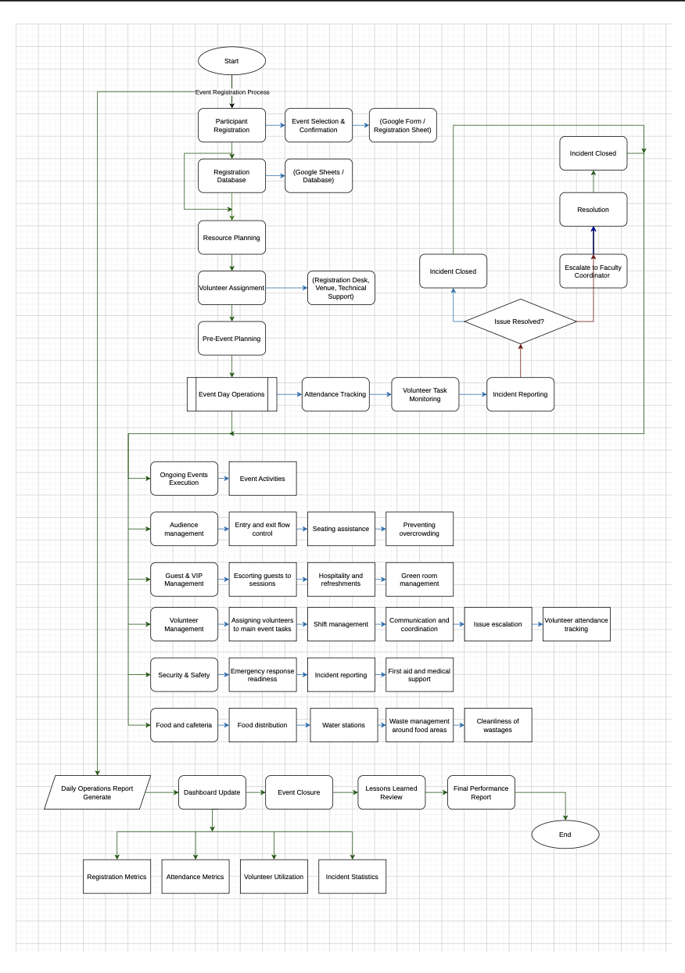
- ER Diagram
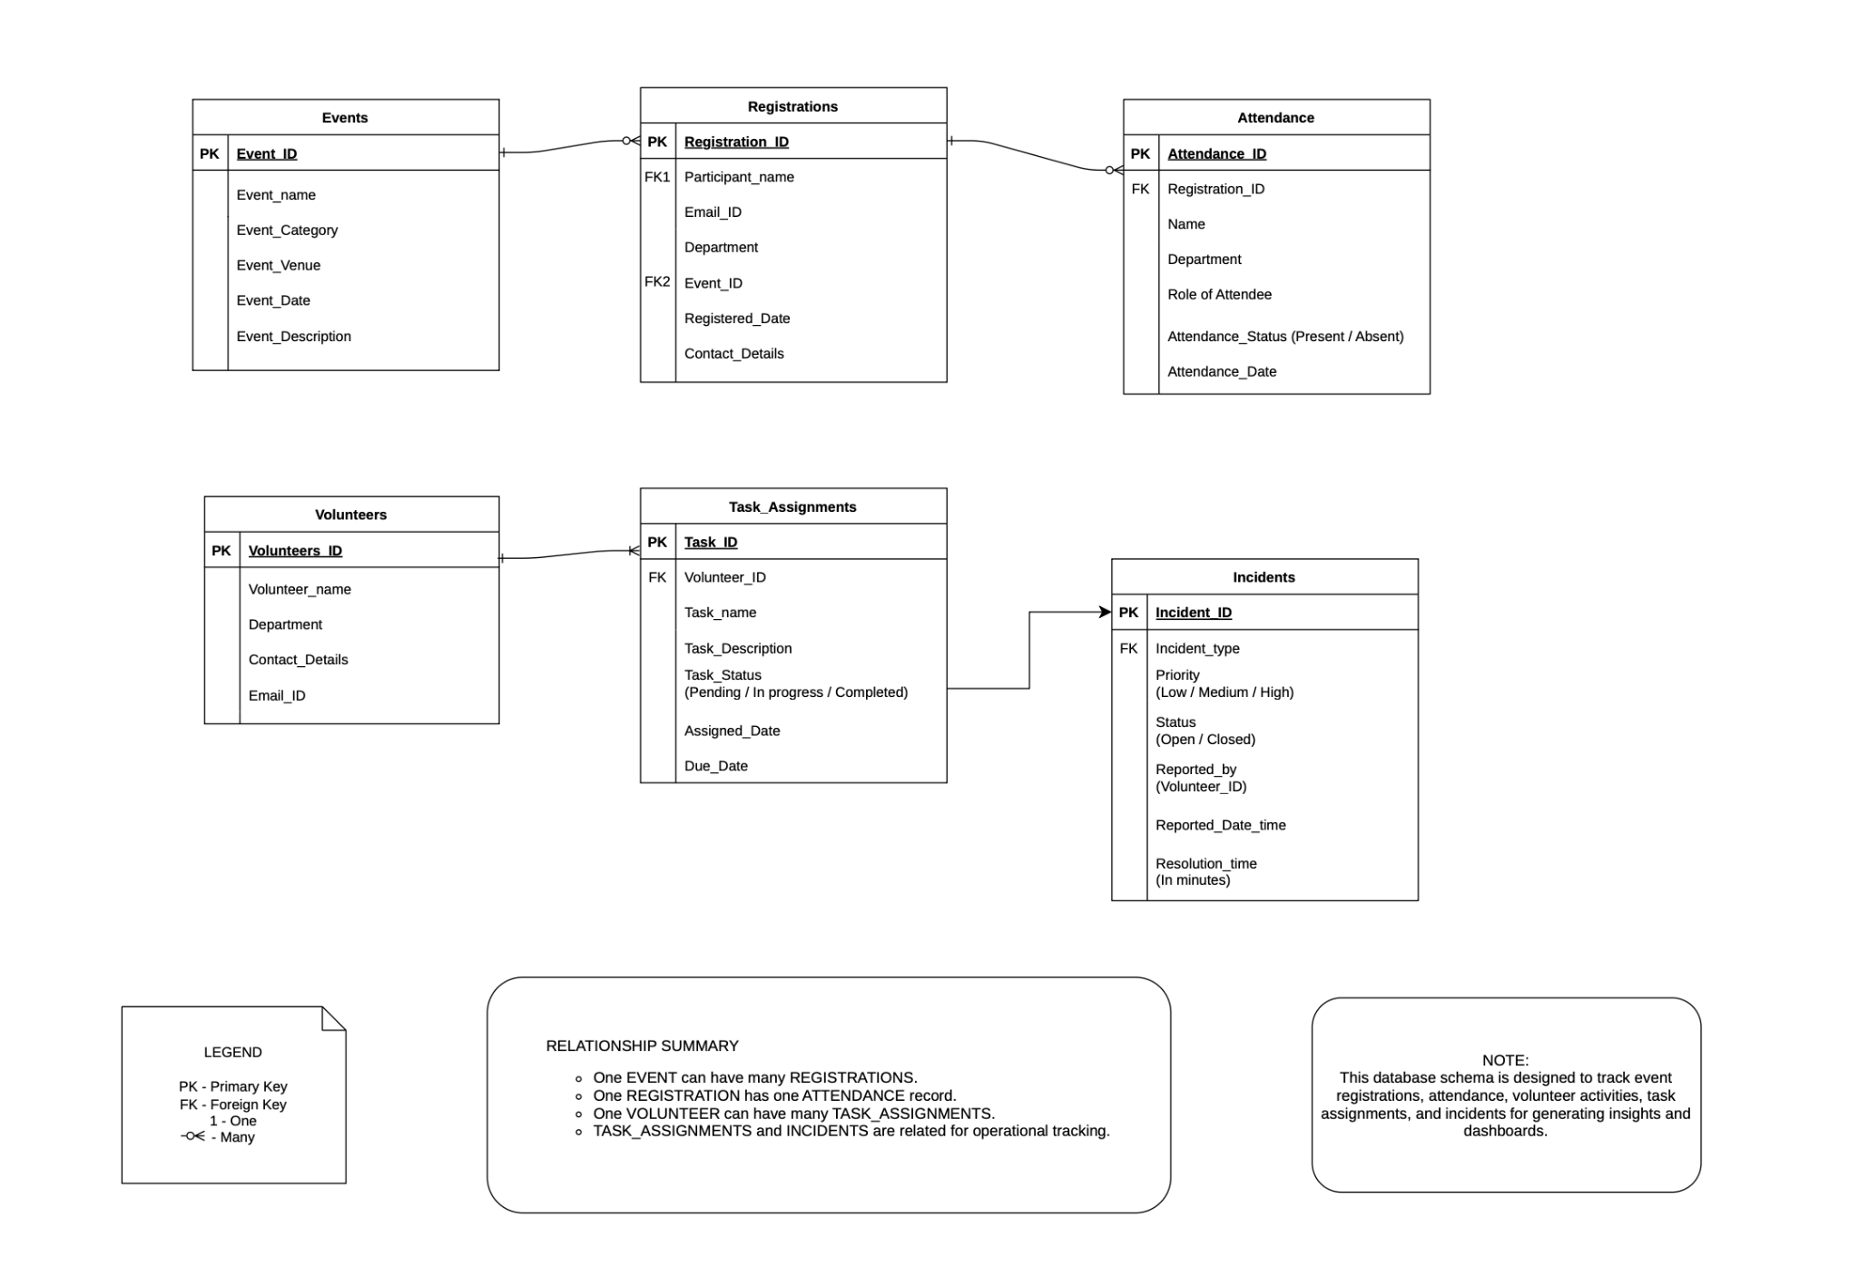
- Dashboard Screenshots
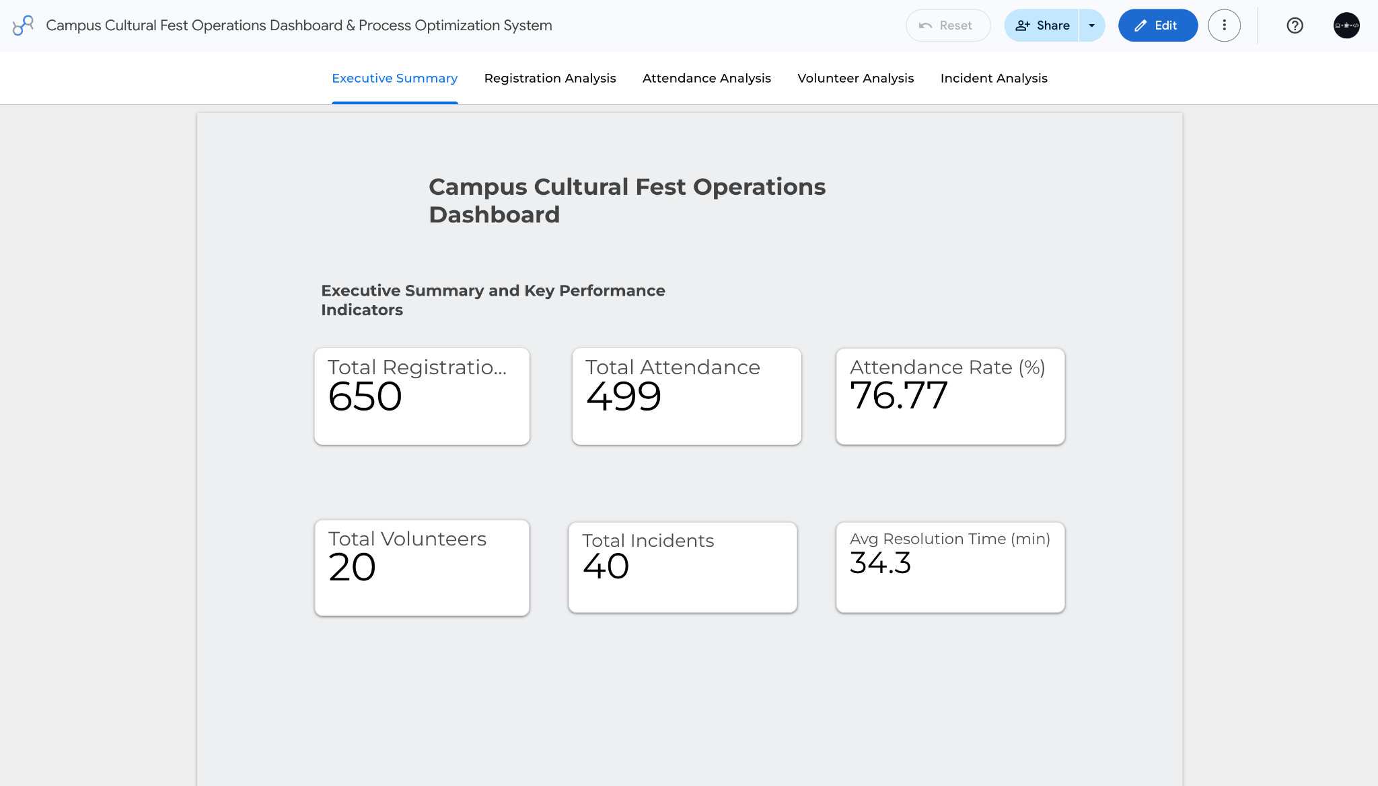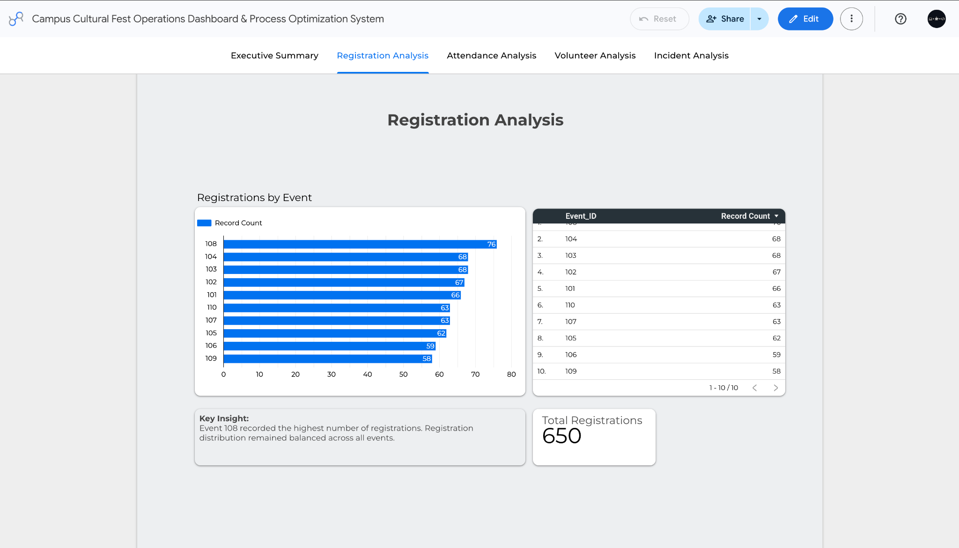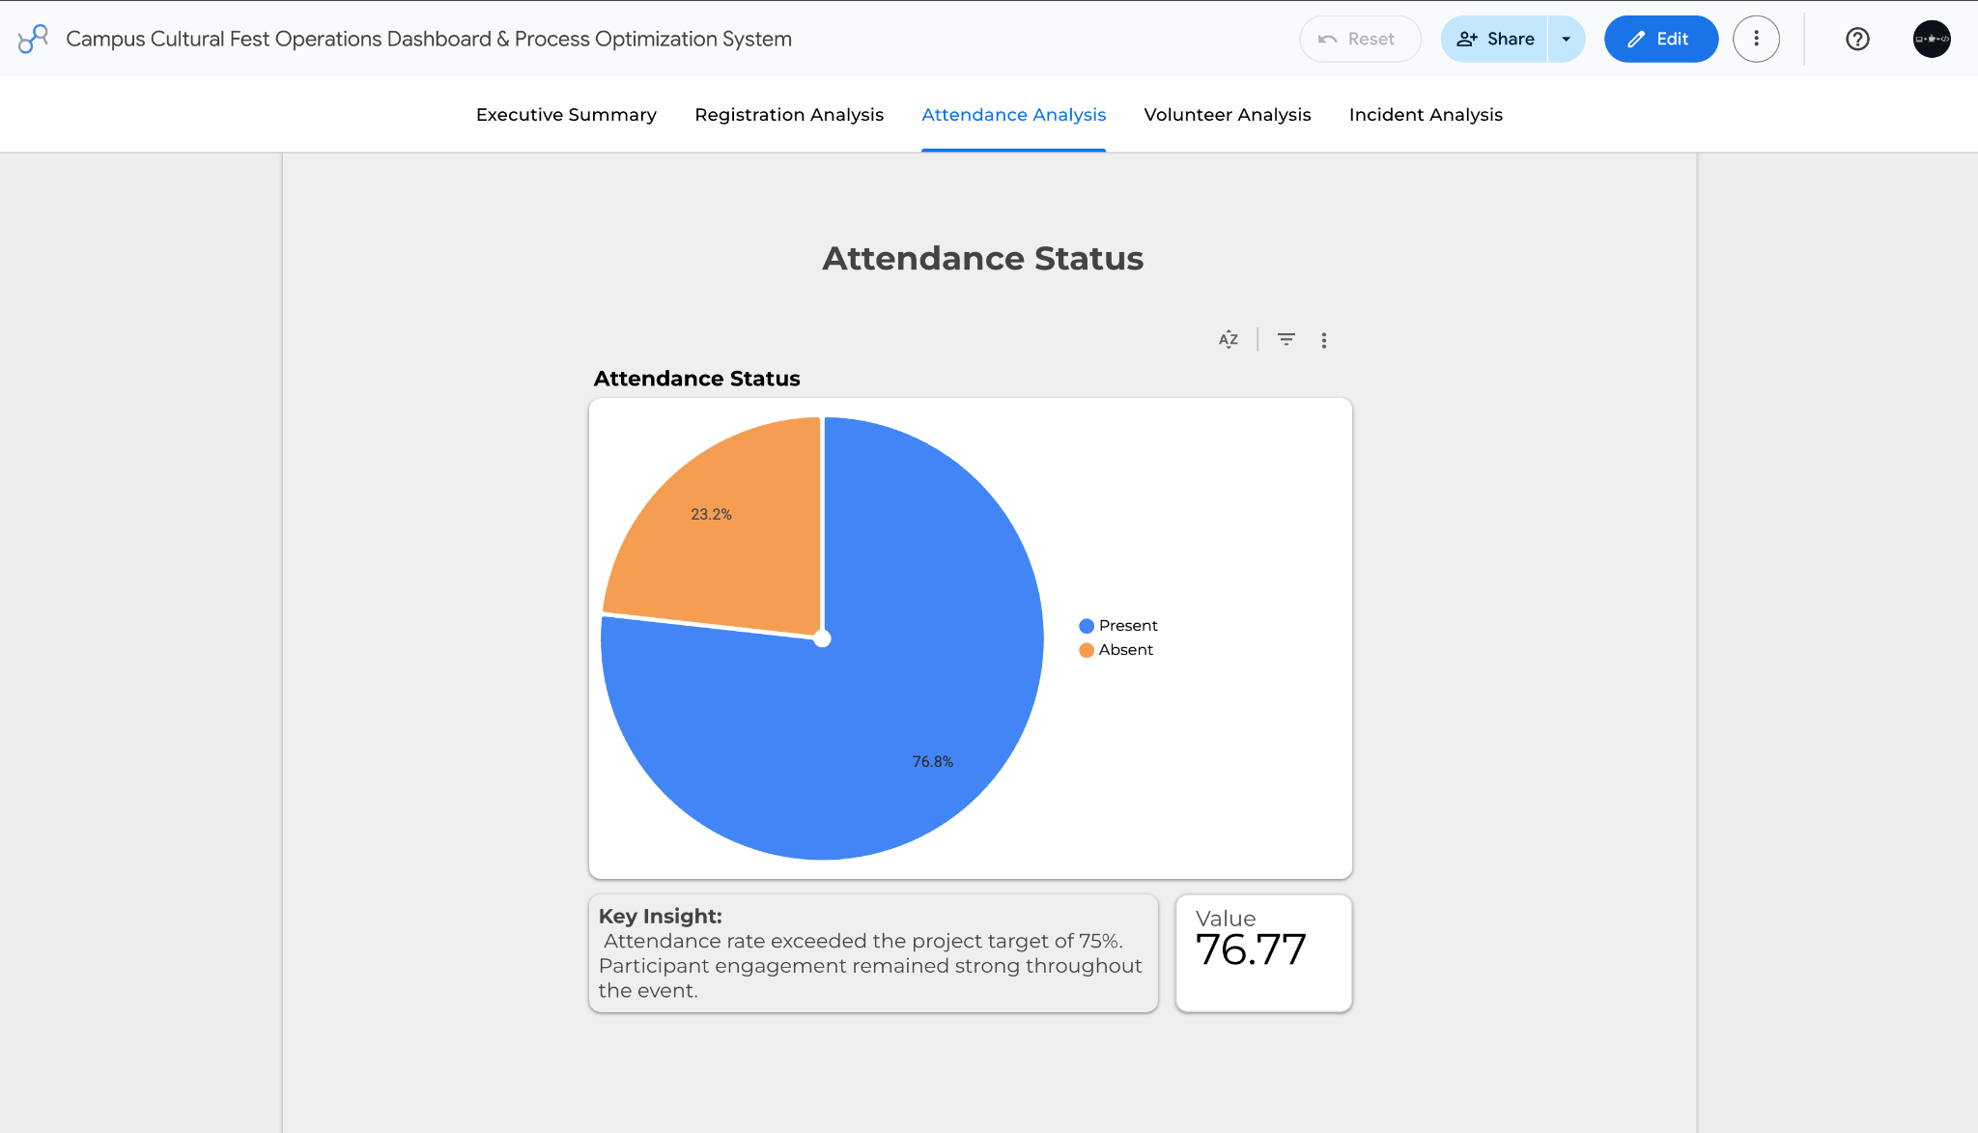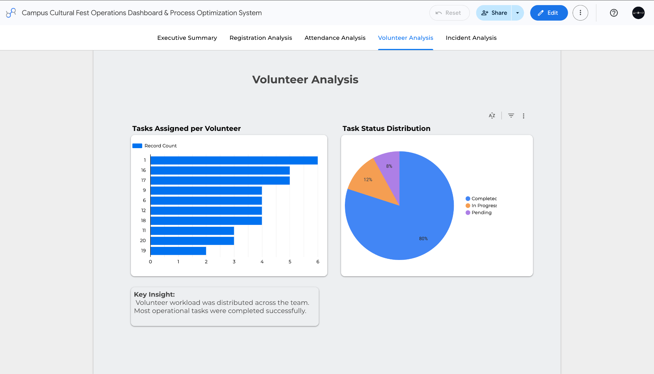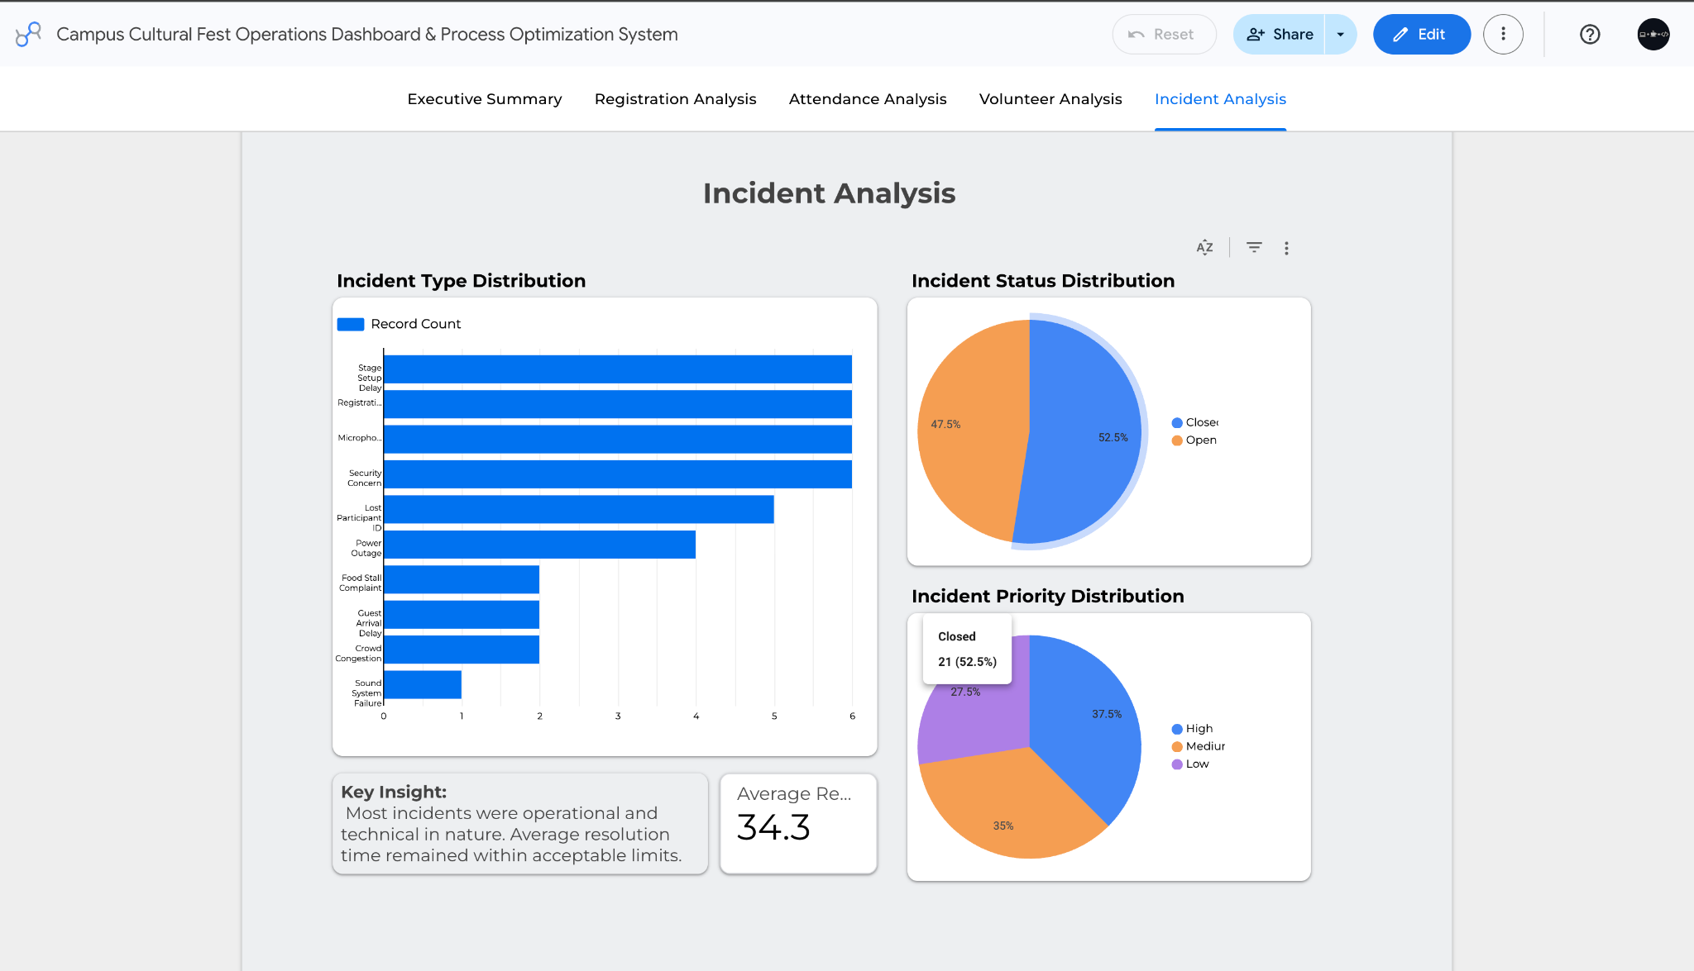
- KPI Summary Table
